Use Case Specification

DMT/RM01/TMP

|  |  |
| --- | --- |
| Project Code | PROJECT_AMS_CSV/Excel_Sheet |
| Project Name | Asset Management System |

|  |  |  |
| --- | --- | --- |
| Prepared/Modified by | Role | Date of Preparation |
| Anusha Godaba | Test Engineer | 27/09/2018 |
| Reviewed by | Role | Date of Review |
| Shashi Kumar | SME |  |
| Approved by | Role | Date of Approval |
| Shubhangi Gurav | Test Manager |  |
| Circulation List |  | Version Number of the template: |
| Version Number | 1 |  |

<<Customer>> REVIEW HISTORY

<<Customer comments on the Use case along with the signed off is tracked here>>

|  |  |  |  |  |  |  |
| --- | --- | --- | --- | --- | --- | --- |
| Version | <<Version number>> |  |  |  |  |  |
| Date | <<Date of Review>> |  |  |  |  |  |
| Reviewed by | << Reviewer Name>> |  |  |  |  |  |
| Reviewed UI Specification doc | << Whether UI Specification doc is reviewed >> |  |  |  |  |  |
| All Open Queries/issues closed | << Whether all the open queries and issues resolved>> |  |  |  |  |  |
| Agreement on Assumptions | <<Whether all the assumptions have been agreed upon by the customer>> |  |  |  |  |  |
| Sign Off | <<Signature>> |  |  |  |  |  |

Disclaimer:

The scope of the project ‘<<Project Name>>’ is restricted to the contents of this signed off use case.

TABLE OF CONTENTS

1.Use Case Name: <<Use Case Name>> 4

2.Actor(s) 4

3.Preconditions 4

4.Flow of Events 4

4.1 Basic Flow 4

4.2 Alternative Flows 5

4.2.1 Alternate Flow 1 5

4.3 Sub Flows 6

4.3.1 Sub Flow 1 6

5.Post Conditions 6

6.Special Requirements 7

7.Extension Points 7

<Name of extension point> 7

8.Business Rules 7

9.Diagrams 8

Use Case Diagram 8

Activity Diagram 9

10.Scenarios 10

Success Scenarios 10

Failure Scenarios 10

11.Issues 10

12.UI Specifications 10

13.Inter System Dependencies 11

14.Integration with an already existing System of the <<Customer>> 11

15.Assumptions 11

REVISION HISTORY OF THE WORK PRODUCT…………………………….. .. 12

Use Case Name: Asset Management System Update

Use Case ID: Asset Management System Website

1.0

**Brief Description**: This usecase describes the process for “Update the asset Details”

Actor(s)

1.Admin

2.Asset Management Sysytem

Preconditions.

1. Website should be accessible by the Admin by visiting the website on the browser
2. The person login for Asset Management System should be a Admin.

###### Flow of Events

4.1 Basic Flow

**Name:** Successful Updation in Asset Management System

1. Admin login into the website
2. Admin clicks on Add/Modify link.
3. Admin clicks “Modify Asset”
4. Admin selects Asset name from the dropdown.
5. Admin clicks on the Modify.
6. Admin is navigated to the different page.
7. Admin modifies description.
8. Admin modifies Asset Quantity.
9. Admin modifies Asset ID.
10. Admin clicks on Update.
11. System displays the message “Asset Details Updated Successfully ”
    1. Alternative Flows

Alternate Flow 1: Successful Updation in Asset Management System

1. Admin login into the website
2. Admin clicks on Add/Modify link.
3. Admin clicks “Modify Asset”
4. Admin selects Asset name from the dropdown.
5. Admin clicks on the Modify.
6. Admin is navigated to the different page.
7. Admin modifies description.
8. Admin modifies Asset Quantity.
9. Admin clicks on Update.
10. System displays the message “Asset Details Updated Successfully ”

Alternate Flow 2: Successful Updation in Asset Management System

1. Admin login into the website
2. Admin clicks on Add/Modify link.
3. Admin clicks “Modify Asset”
4. Admin selects Asset name from the dropdown.
5. Admin clicks on the Modify.
6. Admin is navigated to the different page.
7. Admin modifies Asset Quantity.
8. Admin clicks on Update.
9. System displays the message “Asset Details Updated Successfully ”

Exception Flow 1: unsuccessfull Updation in Asset Management System due to negative asset quantity

1. Admin login into the website
2. Admin clicks on Add/Modify link.
3. Admin clicks “Modify Asset”
4. Admin selects Asset name from the dropdown.
5. Admin clicks on the Modify.
6. Admin is navigated to the different page.
7. Admin modifies description.
8. Admin enters negative value in Asset Quantity.
9. Admin clicks on Update.
10. System displays the error message “Please Enter Positive Asset Quantity”

Exception Flow 2: unsuccessfull Updation in Asset Management System due to invalid asset description

1. Admin login into the website
2. Admin clicks on Add/Modify link.
3. Admin clicks “Modify Asset”
4. Admin selects Asset name from the dropdown.
5. Admin clicks on the Modify.
6. Admin is navigated to the different page.
7. Admin enters invalid description(special characters,numeric values).
8. Admin modifies Asset Quantity.
9. Admin modifies Asset ID.
10. Admin clicks on Update.
11. System displays the error message ”Please Enter Valid Description”

Exception Flow 3: unsuccessfull Updation in Asset Management System due to Web Server Down and negative value in asset quantity

1. Admin login into the website
2. Admin clicks on Add/Modify link.
3. Admin clicks “Modify Asset”
4. Admin selects Asset name from the dropdown.
5. Admin clicks on the Modify.
6. Admin is navigated to the different page.
7. Admin enters invalid description(special characters,numeric values).
8. Admin enters negative value in Asset Quantity.
9. Admin modifies Asset ID.
10. Admin clicks on Update.
11. System displays the error message ”Please Enter Valid Asset details”

Exception Flow 4: unsuccessfull updation in Asset Management System due To Web Server Down

1.Admin login into the website

2.Admin clicks on ADD/Modify asset link

3.Admin clicks on modify asset link

4.Admin modifies Asset description.

5.Admin modifies Asset quantity.

6.Admin modifies Asset ID.

7.System displays the message “Web Server Down”

Exception Flow 5: unsuccessfull updation in Asset Management System due To Database Connectivity Error

1.Admin login into the website

2.Admin clicks on ADD/Modify link

3.Admin clicks on modify asset link.

4.Admin modifies Asset description.

5.Admin modifies Asset quantity.

6.Admin modifies Asset ID.

7.Admin clicks on Update.+00

7.System displays the message “Database Connectivity Error”

Exception Flow 6: unsuccessfull updation in Asset Management System due To Network Connectivity Error

1.Admin login into the website

2.Admin clicks on ADD/Modify link

3.Admin clicks on ADD asset link

4.Admin modifies Asset description.

5.Admin modifies Asset quantity.

6.Admin modifies Asset ID.

7.System displays the message “Network Connectivity Error”

Post Conditions

| Flow Name | Post Condition |
| --- | --- |
| Successful Modification of asset data in Asset Management System | System displays the message “Asset Details Updated Successfully” |
| Unsuccessful updation in asset management system due to negative asset quantity | System displays the error message “Please Enter Positive Asset Quantity” |
| Unsuccessful updation in asset management system due to negative asset quantity due to invalid description | The system should display an error message to the Admin “Please Enter Valid Description” |
| Unsuccessful updation in asset management system due to negative asset quantity due to web server and negative value in asset quantity | The system should display an error message to the Admin “Please Enter the Valid Asset details”. |
| Web Server Down | The system should display an error message to the Admin regarding web server unavailability problem. |
| Database Connectivity Error | The system should display an error message to the Admin regarding the database connectivity problem. |
| Network Connectivity Error | The system should display an error message to the Admin regarding the network connectivity problem. |

Special Requirements

Performance

* On entering the website URL , users shall have greater than 50Kbps connection speed.
* Application should responce within 6 sec. for all the request by the user.

Availability

* 1. Application is up and running 24*7.

Business Rules

| Business Rule Name | Business Rule Description | System action (if BR fails) |
| --- | --- | --- |
| BR01 | Data stored in description should be alpha numeric | Error message is displayed “Please Enter Valid Description” |
| BR02 | Data stored in Asset Quantity should be Positive | Error message is displayed “Please Enter Positive Asset Quantity” |
| BR03 | Data stored in Description should be Valid. | Error message is displayed “Please Enter Valid Description” |

Diagrams

Use Case Diagram

* 1. For Successful Asset Management System
     1. Admin

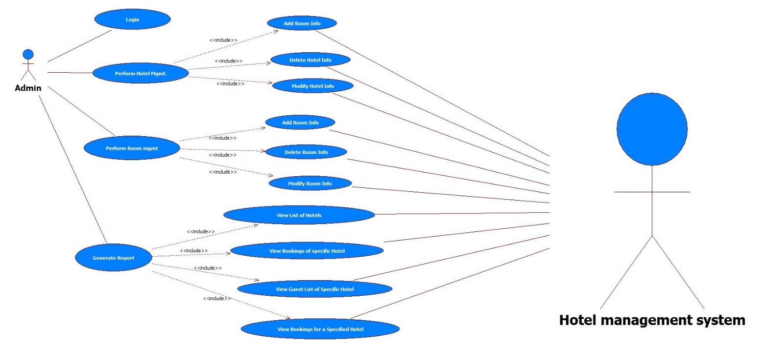

Manager

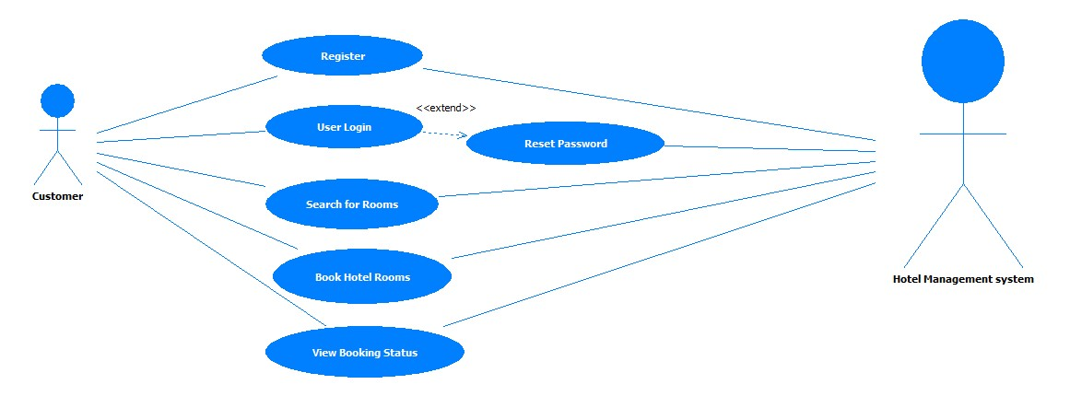

Scenarios

Success Scenarios

* Successful Updating of Exporting Details in Asset Management System

Failure Scenarios

* Failed the details not exported into CSV/Excel in Asset Management System

Issues

1. What is to be done if web server is down?
2. What is to be done if the link does not get opened?
3. What is to be done if there is data connectivity error?
4. What is to be done if the form is not getting submitted even after entering valid field details without any alerts for errors?

Extension Points

Extension in Alternate FLOW 1:

In step 11, of alternative flow 1 if the Admin clicks on Reset Button

1. The Admin can click the link again.

Assumptions

1.Admin can easily export the data into CSV/Excel Sheet.

2.Admin clicks on link

REVISION HISTORY OF THE WORK PRODUCT

<to be maintained by projects>

|  |  |  |  |  |  |
| --- | --- | --- | --- | --- | --- |
| # | Date | Version # | Section Changed | Details of changes made | Approved By |
| 1 |  |  |  |  |  |
| 2 |  |  |  |  |  |